**CSEN 241 Cloud Computing**

**HW1**

**Rohan Pandey W1644990** [**rpandey4@scu.edu**](mailto:rpandey4@scu.edu)

|  |  |  |
| --- | --- | --- |
| Sno | Rubric point | Data |
| 1 | Creation of three different disk images: 5 points | Qcow2, Raw, Docker |
| 2 | Present main steps to enable a QEMU VM. In addition, please present the detailed QEMU commands, and VM configurations: 10 points | Steps to follow |
| 3 | Present main steps to create the Docker container. This must show your steps in creating your own image and your image history! Do not copy any manage Docker containers (and some other operations which you think are also important): 10 points | Docker setup steps |
| 4 | Proof of experiment. Include screen snapshots of your Docker and QEMU running environments for each experiment: 10 points | [Bash Scripts & Screen recording of QEMU test](https://drive.google.com/drive/u/0/folders/11XXUf7CcIlEXEh1RqIBU5oeW1sQOCKeL) |
| 5 | Present your measurements in given different scenarios for each virtualization technology: 20 points | Testing Measurements & detailed analysis (+ pt6) |
| 6 | Shell scripts for running the experiment: 10 points | [Test Scripts & configuration launch scripts](https://drive.google.com/drive/folders/1H6MInUUgGd1EuBXoGqpL33o0AwBHsQE_?usp=drive_link) |
| 7 | Presentation and analysis of the performance data: 20 points | Refer point 5 |
| 8 | Understandability/Neatness of your report and Git: 5 points | Git |
| 9 | Extra Credit I: Run the all the QEMU experiment on disk image with encryption Use encrypt.format=luks and provide all experiment details. 5 points | Only image done |
| 10 | Extra Credit II: Provide the correct Vagrant and Docker files for your VM and Docker Container. 5 points (3 for vagrant 2 for Docker file) | NA |

***Steps to Run Bash scripts-***

1. ***Launch the VM using launch scripts (eg. config_1_scripts_raw_launch) or direct command***
2. ***Run test cases using script “sysbench_scripts”***
3. ***Refer results in form of*** [***recording***](https://drive.google.com/drive/u/0/folders/11XXUf7CcIlEXEh1RqIBU5oeW1sQOCKeL) ***(For QEMU) , for docker results scripts are submitted & performance analysis is captured in report***

QEMO installation & 3 Different disk images-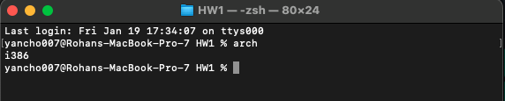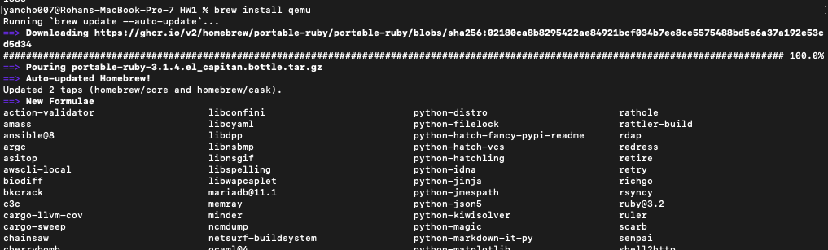

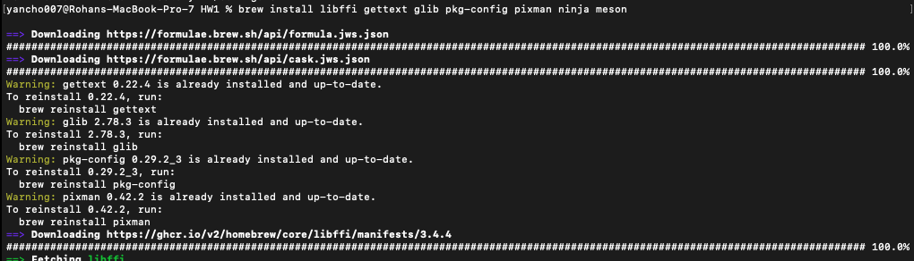

## Steps- Step 1:-Making Ubuntu image (raw,qcow2, encrypted,Docker)

1. qemu-img create ubuntu.img 20G -f qcow2
2. qemu-img create ubuntu_raw.img 20G -f raw
3. qemu-img create -f qcow2 -o encrypt.format=luks -o key-secret=mysecret -o key-size=256 ubuntu_encrypted.img 20G-
4. This command creates an encrypted QCOW2 disk image named ubuntu_encrypted.img with a size of 10 gigabytes.
5. The encryption is done using LUKS (Linux Unified Key Setup).
6. key-secret=mysecret specifies the passphrase to be used for encryption.
7. key-size=256 specifies the key size (adjust as needed).

**Step 2:** - Launching VM

1. Launching VM using base command & Bash scripts
2. Launching VM using 4 configurations of CPU & ram & bash scripts

|  |  |  |
| --- | --- | --- |
| Sno | CPU/smp | Memory |
| 1 | 4 | 4096 |
| 2 | 8 | 8192 |
| 3 | 4 | 8192 |
| 4 | 8 | 4096 |

**Step 3**: -Testing

1. Testing each image on 6 test cases (2 CPU,2Memory, 2Fileio) using bash scripts

**Step 4:** -Result Comparison- Qcow2 Vs raw Vs encrypted Vs Docker

Following is the explanation for all the arguments we have used in our-

* -accel Used to enable an accelerator. Depending on the target architecture, kvm, xen, hax, hvf, nvmm, whpx or tcg can be available
* -m Stands for memory. We have currently supplied 2G as the argument value which means we are allocating 2GB RAM memory for our VM
* -smp Stands for number of cores. We have currently given the argument value as 2, which means that we have allocated 2 cores for our VM

***Note:*** We would be updating -m and -smp values when running for different configurations.

Qcow2 Image:-

***Launch VM***- ***sudo qemu-system-x86_64 -hda ubuntu.img -boot d -cdrom ./ubuntu-20.04.6-live-server-amd64.iso -m 4096 -boot strict=on***



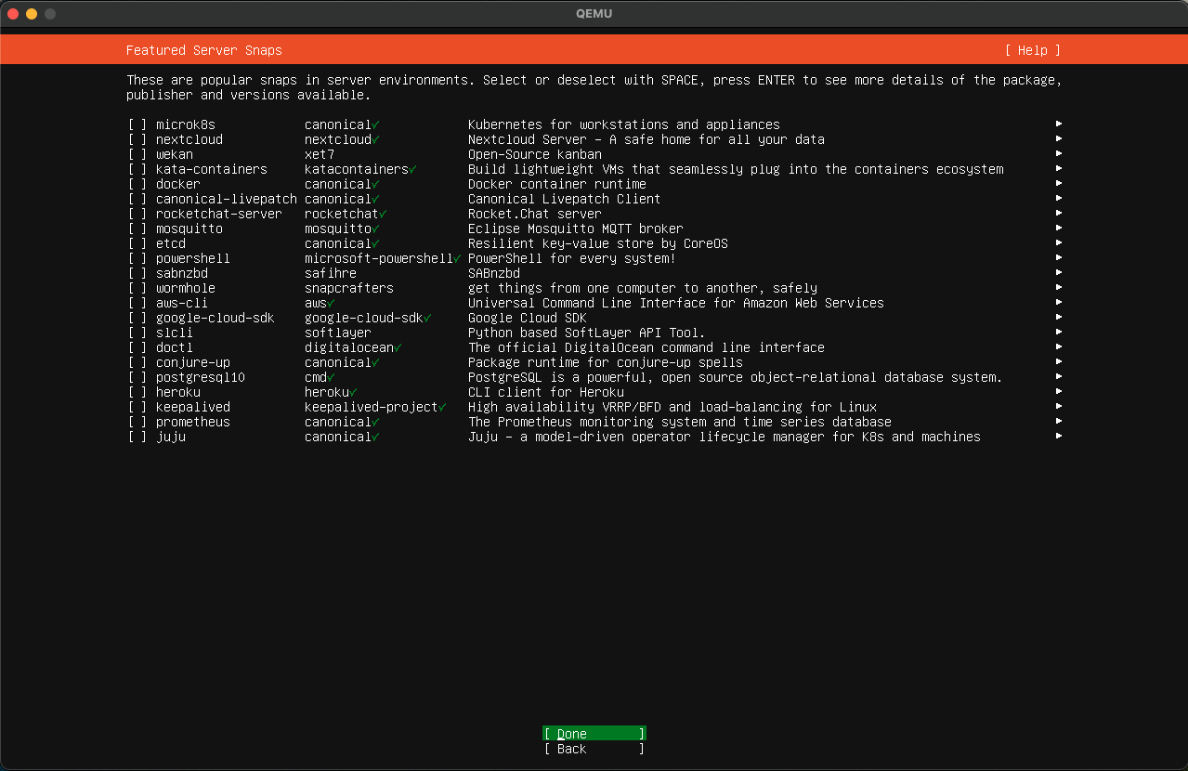

Launching VM on QEMU using bash script (included in submission)-

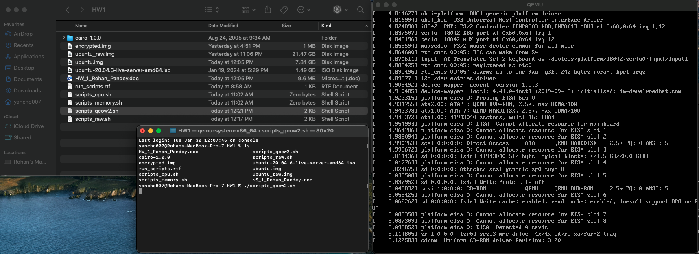

4 Configurations for QEMU -Ubuntu VM-

**Base command**-qemu-system-x86_64 -hda ubuntu.img -boot d -m 2046 -boot strict=on

We will test our image on following 4 test cases using sysbench**-**

|  |  |  |  |
| --- | --- | --- | --- |
| Sno | Description | CPU/smp | Memory |
| 1 | Config 1 | 4 | 4096 |
| 2 | Config 2 | 8 | 8192 |
| 3 | Config 3 | 4 | 8192 |
| 4 | Config 4 | 8 | 4096 |

**Running**

**Configuration-1- Launch using bash script file**

(config_1_scripts_qcow2_launch.sh) or

Command- qemu-system-x86_64 -hda ubuntu.img -boot d -m 4096 -smp 4,maxcpus=4 -boot strict=on

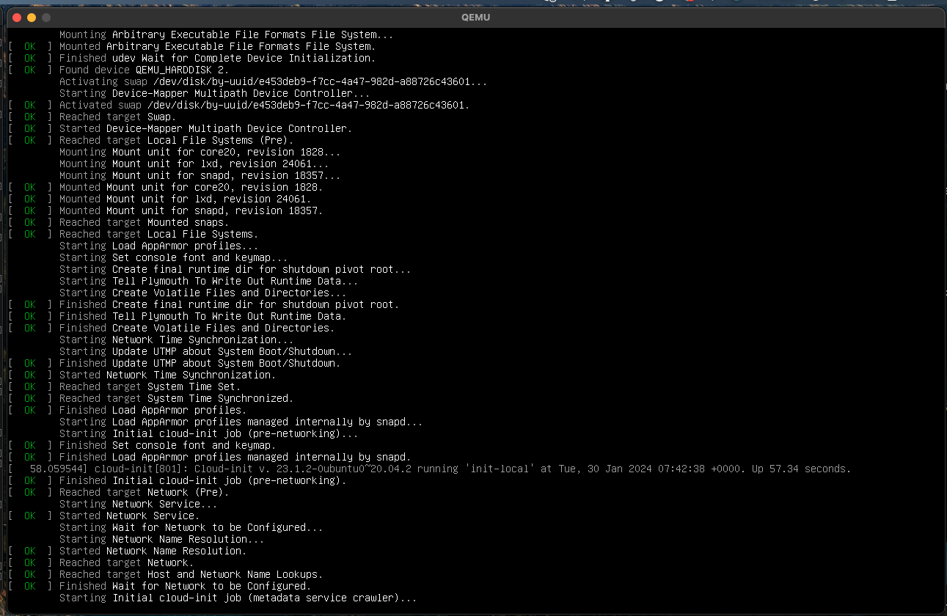

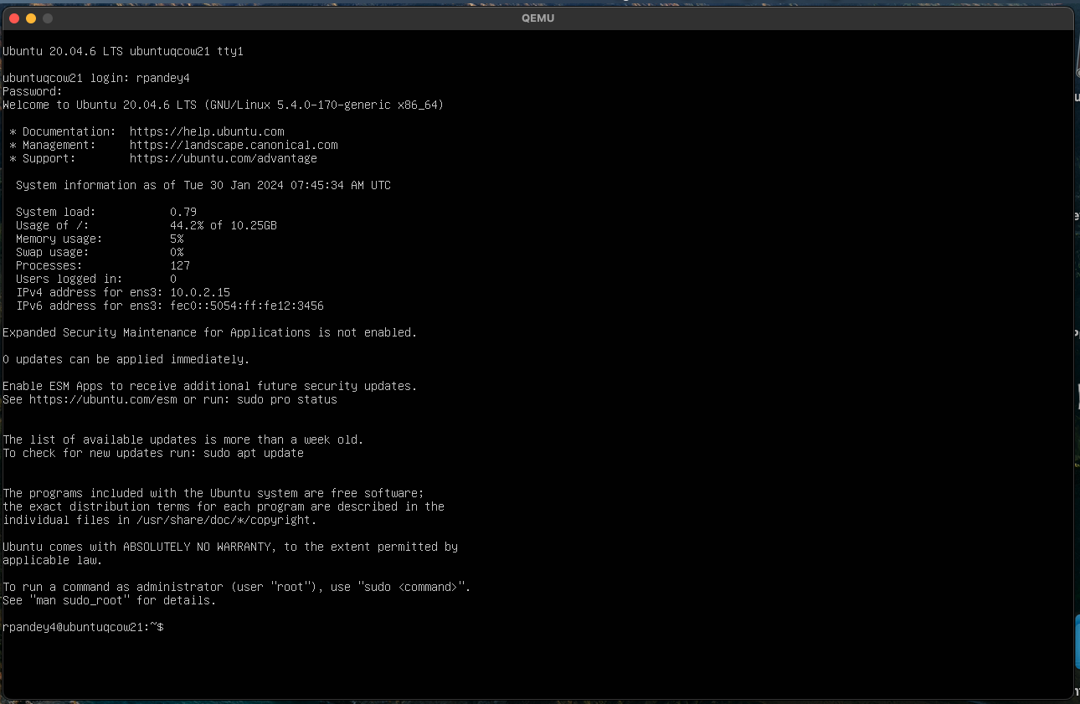

Sysbench installation & version check- sysbench -1.0.18

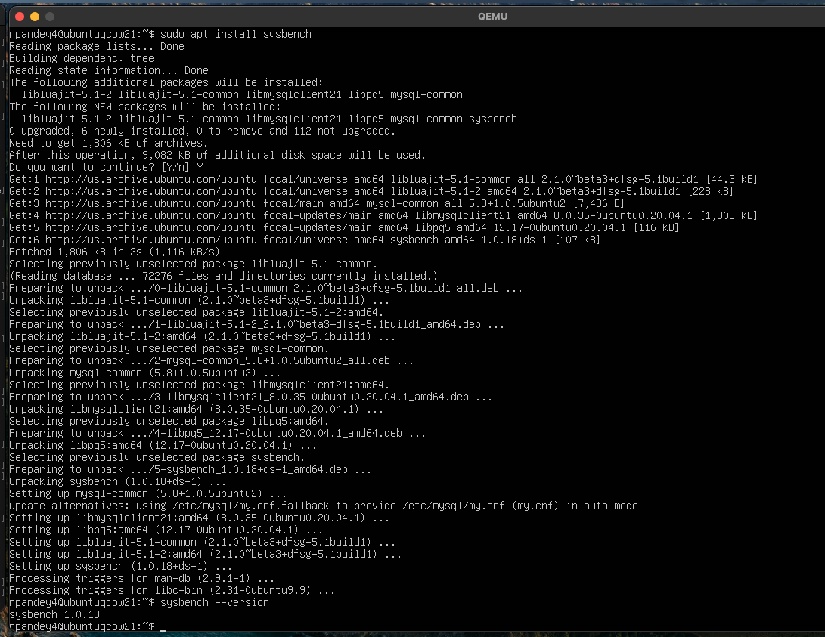

Generating Bash scripts with 6 test cases & 5 iterations of each

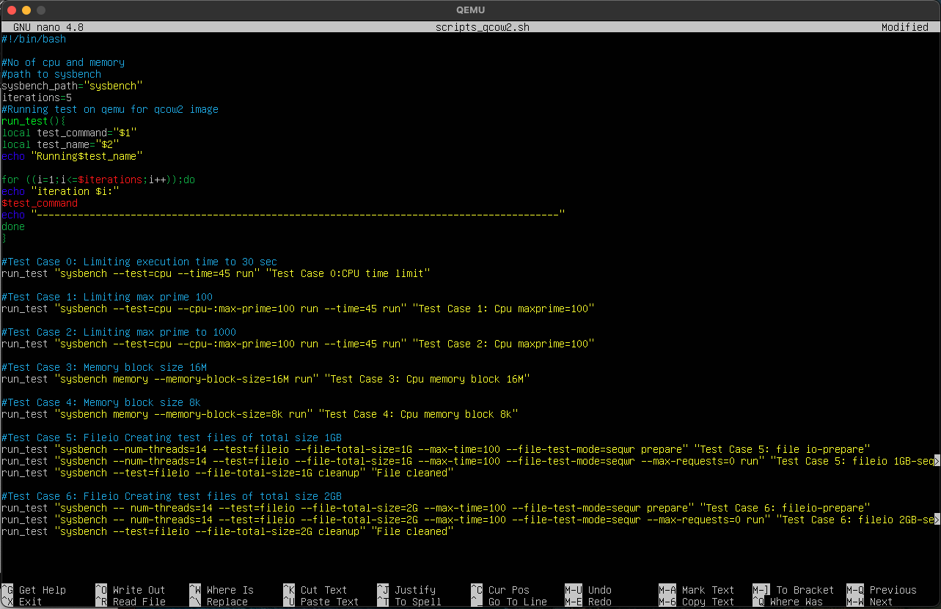

**3 CPU cases-**

* sysbench --test=cpu --time=45 run"
* sysbench --test=cpu –cpu-max-prime=100 --time=45 run
* sysbench --test=cpu –cpu-max-prime=1000 --tIme=45 run

**2 memory cases-**

* sysbench memory --memory-block-size=16M run
* sysbench memory --memory-block-size=8k run

The --memory-block-size option in Sysbench is used to define the block size for memory allocation and deallocation operations. This option is relevant when running memory-related tests with Sysbench. Below are a few test cases for --memory-block-size

1. **fileio cases-**

**Test Case 1 (Sequential R/W) :** Creating test files of total size 1GB.

sysbench --test=fileio --file-total-size=1G prepare

* sysbench --test=fileio --file-total-size=1G --file-test-mode=seqwr --max-time=250 --max-requests=0 run
* Removing test files:- sysbench --test=fileio --file-total-size=1G cleanup

**Test Case 2 (Random R/W):** Creating test files of total size 2GB.

* sysbench --test=fileio --file-total-size=2G prepare
* sysbench --test=fileio --file-total-size=2G --file-test-mode=rndrw --max-time=250 --max-requests=0 run
* Removing test files:- sysbench --test=fileio --file-total-size=1G cleanup

[Test Results & screen recording.](https://drive.google.com/drive/folders/1nz14JWX65DIUzT2_SsaSaKLIUPZ9uzmU?usp=drive_link)

**Configuration-2- Launch using bash script file**

Command- qemu-system-x86_64 -hda ubuntu.img -boot d -m 8192 -smp 8,maxcpus=8 -boot strict=on

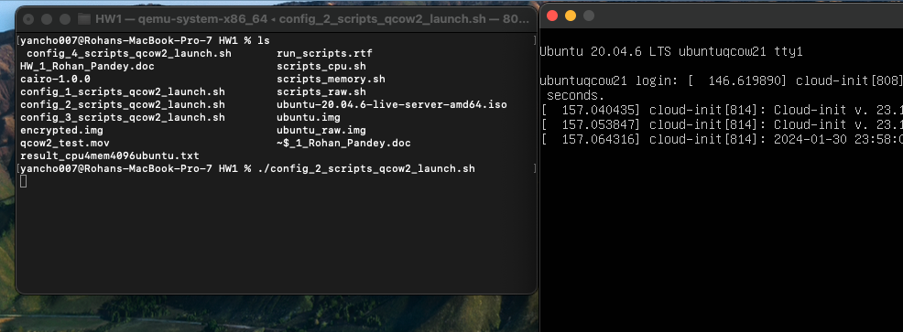

Configuration verification from ubuntu VM-

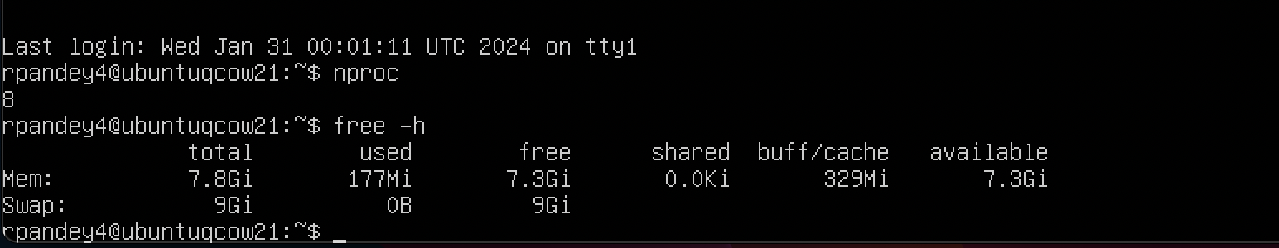

Using Sysbench bash script & launch it- run_scripts.sh

[Test Results & screen recording.](https://drive.google.com/drive/folders/1nz14JWX65DIUzT2_SsaSaKLIUPZ9uzmU?usp=drive_link)

**Configuration-3- Launch using bash script file**

Command- qemu-system-x86_64 -hda ubuntu.img -boot d -m 8192 -smp 4,maxcpus=4 -boot strict=on

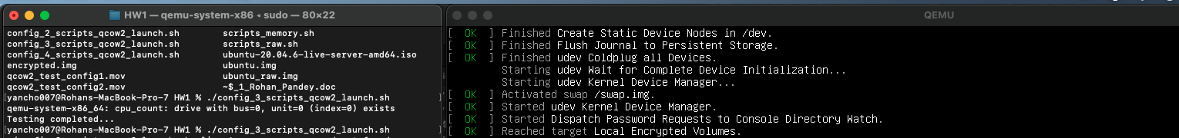

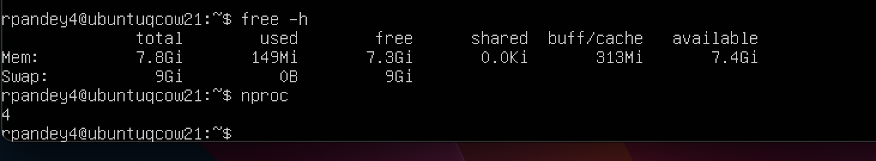

[Test Results & screen recording.](https://drive.google.com/drive/folders/1nz14JWX65DIUzT2_SsaSaKLIUPZ9uzmU?usp=drive_link)

**Configuration-4- Launch using bash script file**

qemu-system-x86_64 -hda ubuntu.img -boot d -m 4096 -smp 8,maxcpus=8 -boot strict=on

Verifying system configurations

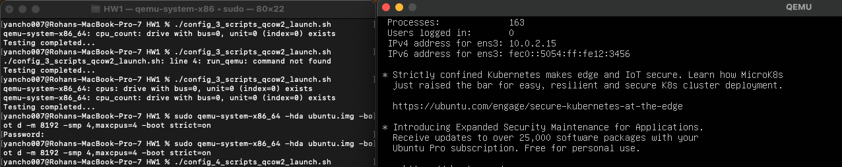

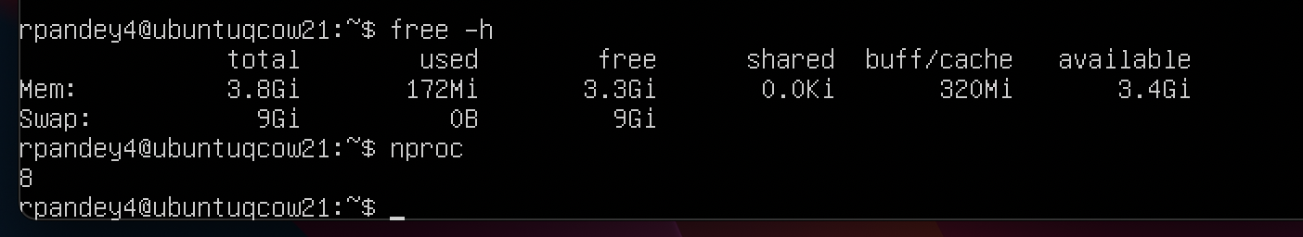

Using Sysbench bash script & launch it- run_scripts.sh

[Test Results & screen recording.](https://drive.google.com/drive/folders/1nz14JWX65DIUzT2_SsaSaKLIUPZ9uzmU?usp=drive_link)

Raw Image->

***Install QEMU-***

Command-sudo qemu-system-x86_64 -hda ubuntu_raw.img -boot d -cdrom ./ubuntu-20.04.6-live-server-amd64.iso -m 2046 -boot strict=on



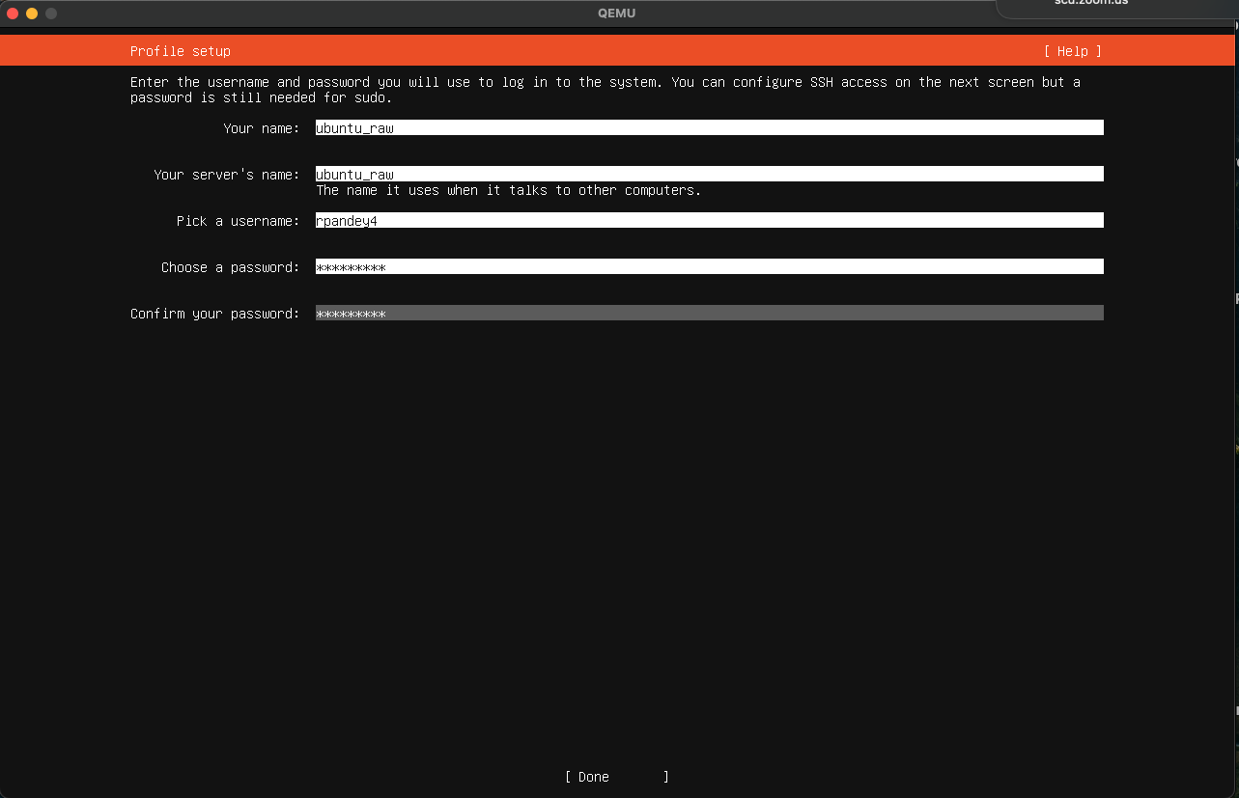

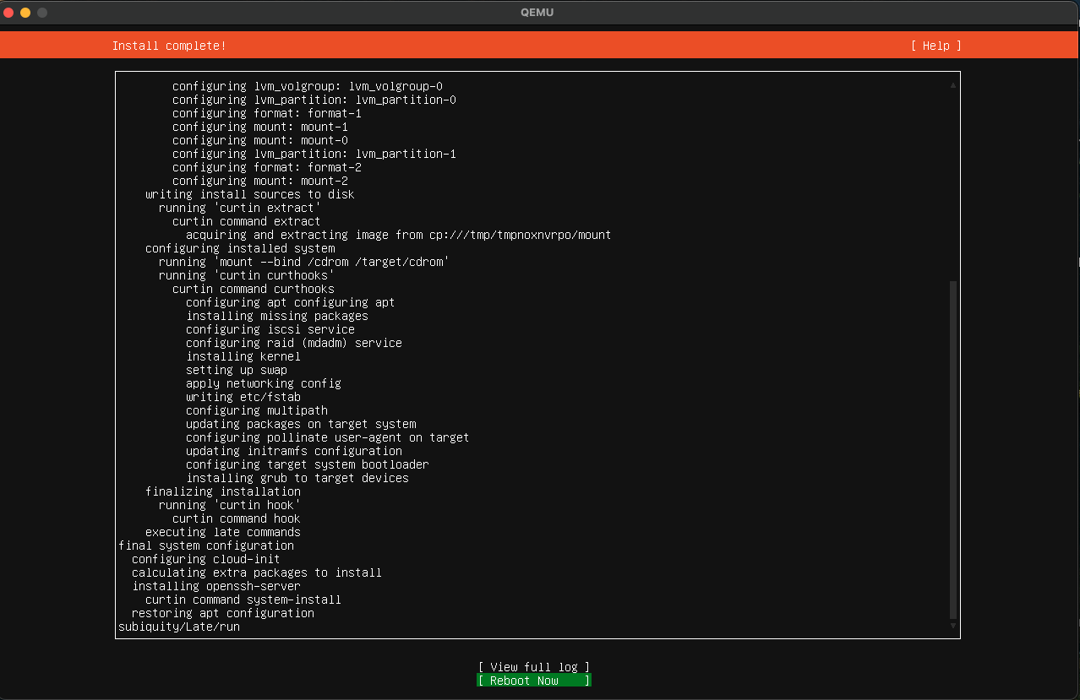

Launching VM on QEMU using bash script (included in submission)-

**4 Configurations for QEMU VM**-

|  |  |  |
| --- | --- | --- |
| Sno | CPU/smp | Memory |
| 1 | 4 | 4096 |
| 2 | 8 | 8192 |
| 3 | 4 | 8192 |
| 4 | 8 | 4096 |

* Base Command- >sudo qemu-system-x86_64 -hda ubuntu_raw.img -boot d -m 2046 -boot strict=on

We will test our image on following 4 test cases using sysbench-



**Running**

**Configuration 1: -**

**Bash script-config_1_scripts_raw_launch.sh**

Command- qemu-system-x86_64 -hda ubuntu_raw.img -boot d -m 4096 -smp 4,maxcpus=4 -boot strict=on

Verify configurations of image-

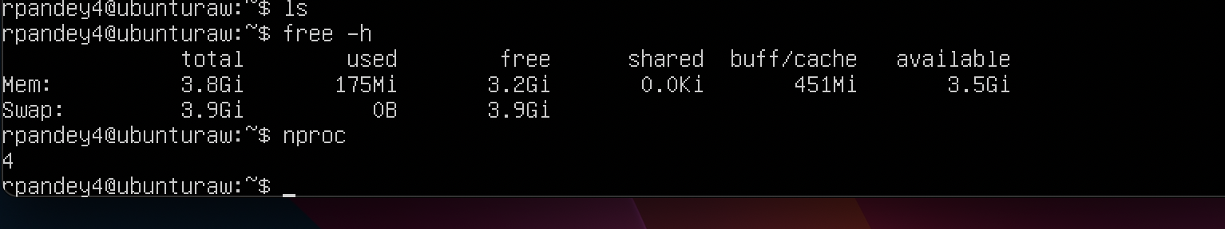

[Test Results and screen recording + Bash scripts](https://drive.google.com/drive/folders/16bcjAwttHqR1I4ILrPxY-SQFacc-aEqn?usp=drive_link)

**Configuration 2: -**

**Bash script- config_2_scripts_raw_launch.sh**

Command- sudo qemu-system-x86_64 -hda ubuntu_raw.img -boot d -m 8192 -smp 8,maxcpus=8 -boot strict=on

System verification-

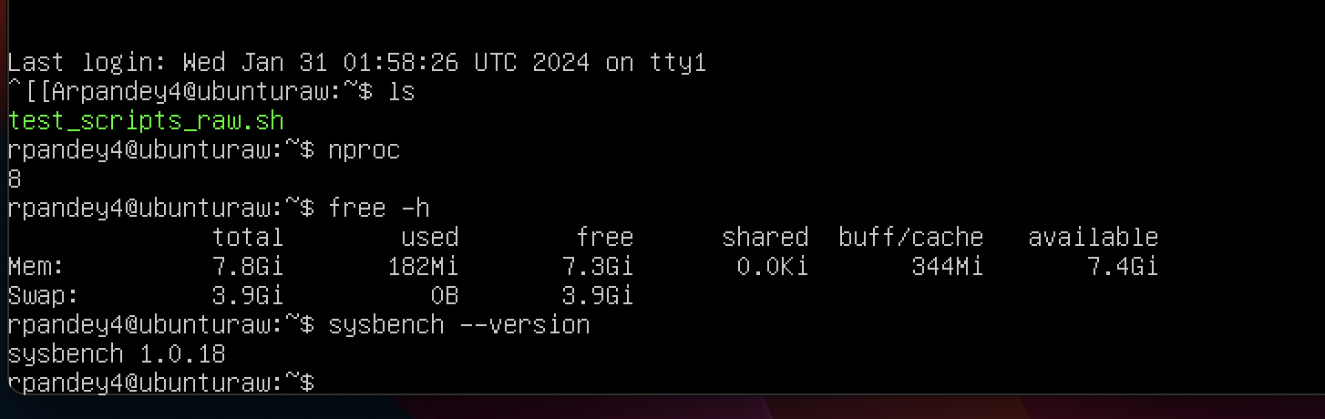

[Test Results and screen recording + Bash scripts](https://drive.google.com/drive/folders/16bcjAwttHqR1I4ILrPxY-SQFacc-aEqn?usp=drive_link)

**Configuration 3: -**

**Bash script- config_3_scripts_raw_launch.sh**

Command- qemu-system-x86_64 -hda ubuntu_raw.img -boot d -m 8192 -smp 4,maxcpus=4 -boot strict=on

System verification

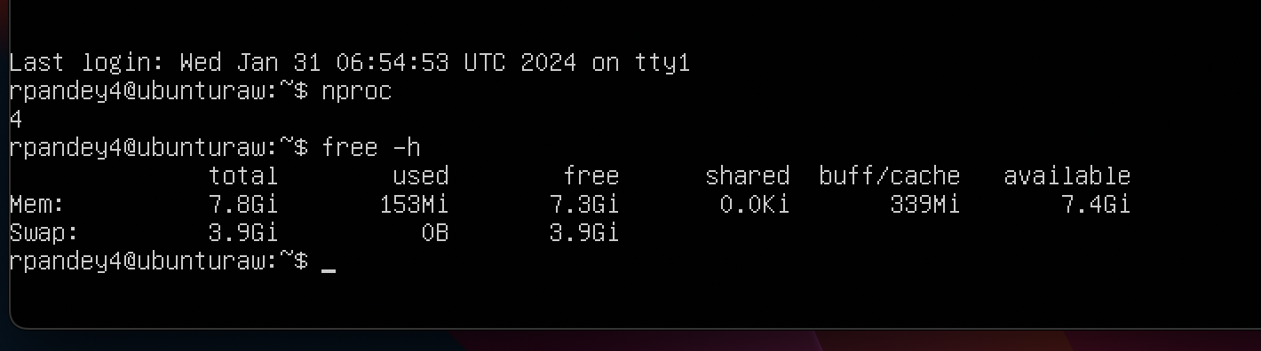

[Test Results and screen recording + Bash scripts](https://drive.google.com/drive/folders/16bcjAwttHqR1I4ILrPxY-SQFacc-aEqn?usp=drive_link)

**Configuration 4: -**

**Bash script- config_4_scripts_raw_launch.sh**

Command- qemu-system-x86_64 -hda ubuntu_raw.img -boot d -m 4096 -smp 8,maxcpus=8 -boot strict=on

System verification

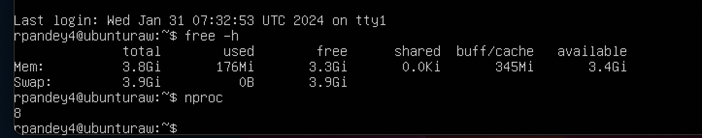

[Test Results and screen recording + Bash scripts](https://drive.google.com/drive/folders/16bcjAwttHqR1I4ILrPxY-SQFacc-aEqn?usp=drive_link)

Encrypted Image->

sudo qemu-system-x86_64 -hda ubuntu_encrypted.img -boot d -cdrom ./ubuntu-20.04.6-live-server-amd64.iso -m 2046 -boot strict=on

qemu-img create -f qcow2 -0 encrypt.format=luks ubuntu_encrypted.img 20G



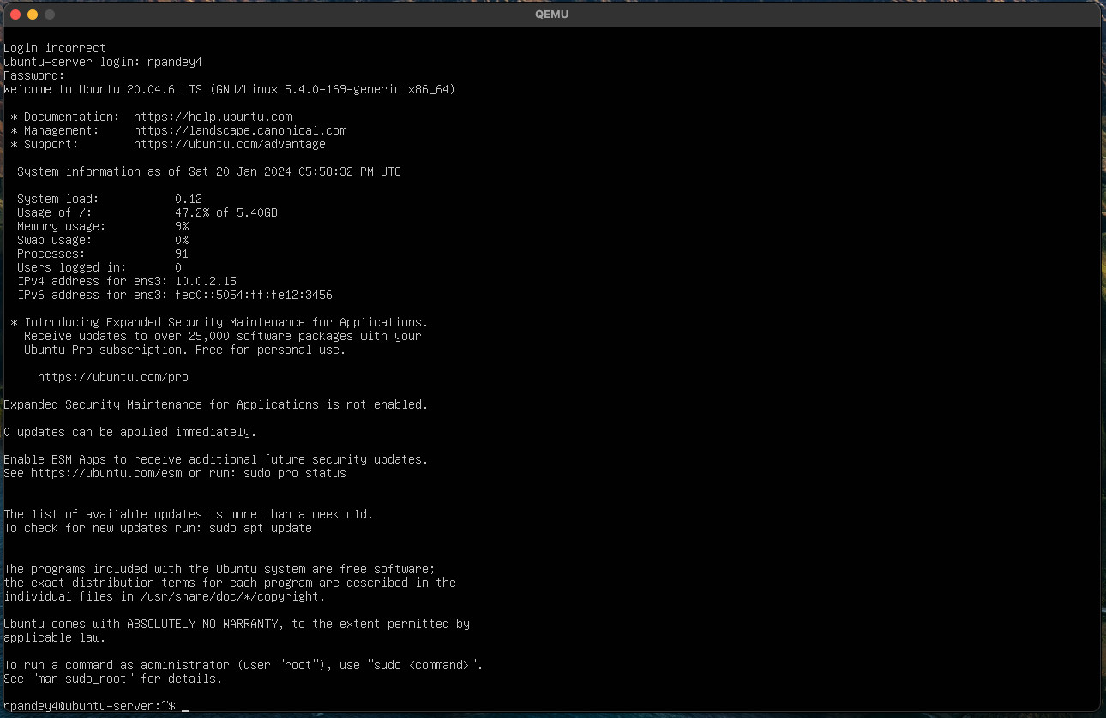

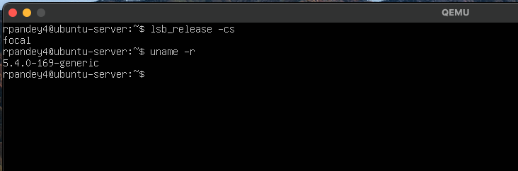

Login to ubuntu

Sysbench installed in VM Ubuntu

***Docker Image->***

***docker pull ubuntu:22.04***

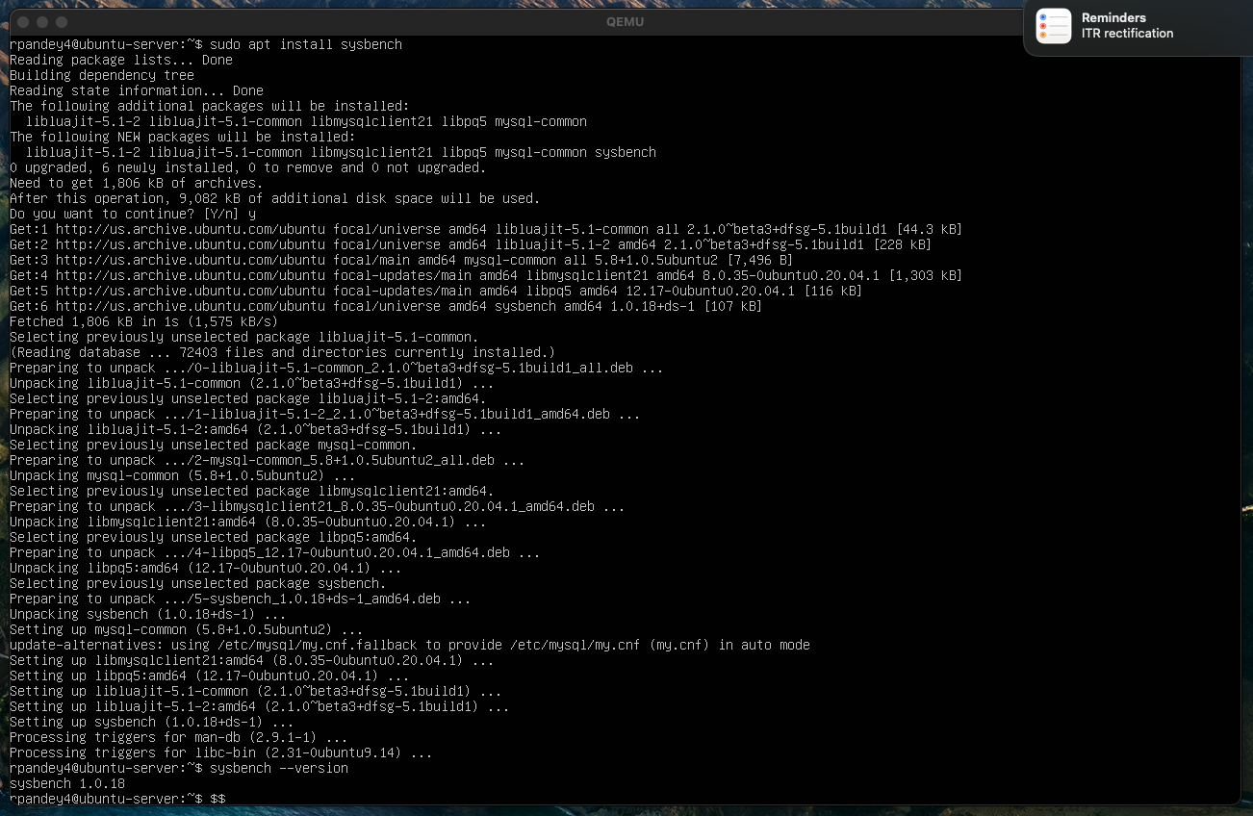

## Steps for Docker Setup->

**Step 1- Downloaded docker image from-https://hub.docker.com/_/ubuntu**

Step 2- started the docker desktop.

Step 3- Sysbench version check 1.0.18 to be installed on both.

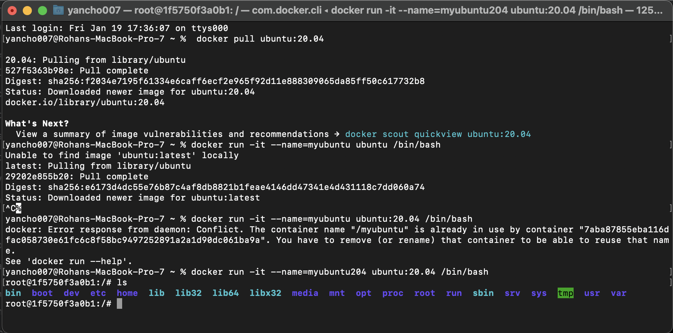

Step 4- Exec commands in ubuntu-

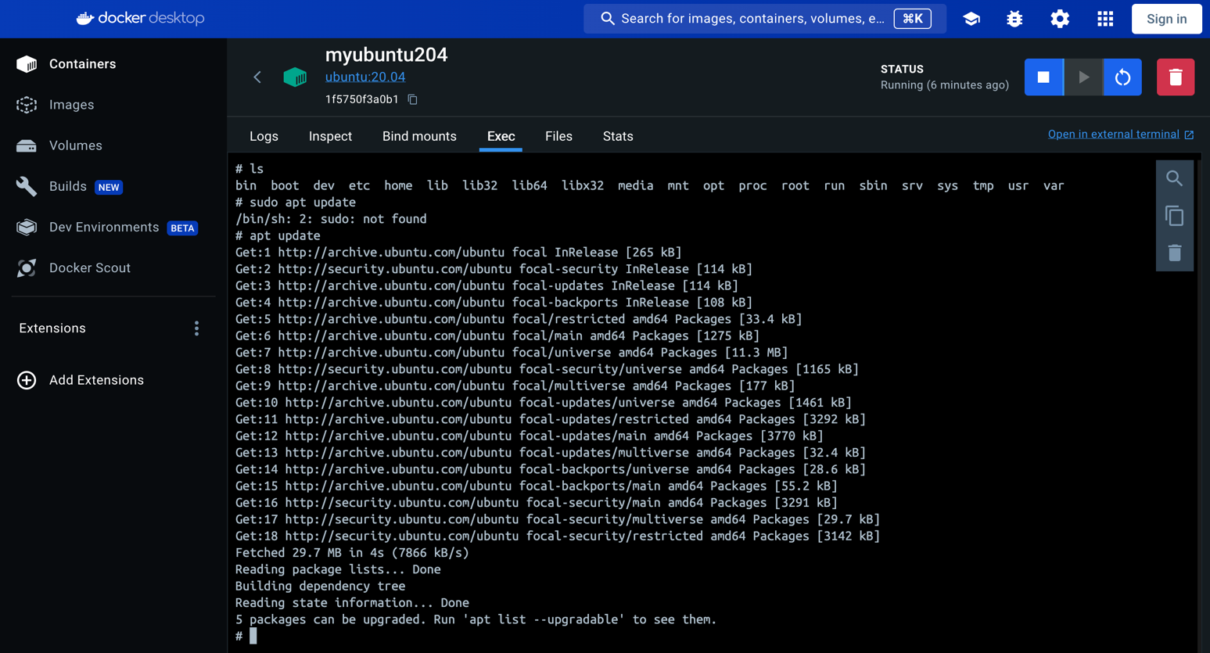

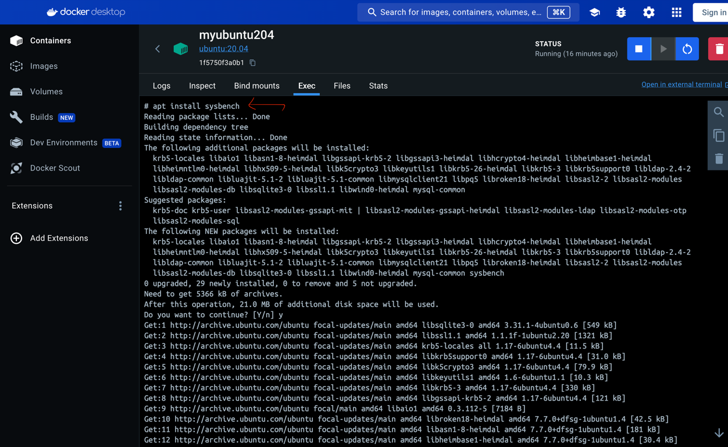

***Sysbench version match-***

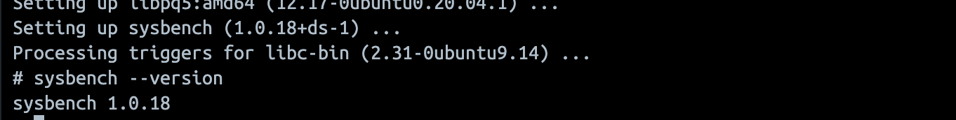

## Docker Exec Syntax-

The "docker exec" syntax for accessing a container’s shell is: -

docker exec -it <container-name-or-id> <shell-executable>

Here’s an explanation of the fields: -

**docker exec**: This tells Docker to execute a command inside a container.

**-it**: These flags (-i and -t) specify that the command should be run in an interactive (-i) session with a pseudo-TTY (-t terminal) attached to the container. This allows you to enter commands and receive output from the container.

**<container-name-or-id>**: This is the name or ID of the container to execute the command in.

**<shell-executable>**: This is the name of the shell executable (a file that contains a program) that you want to use to start an interactive session inside the container. For example, you could specify **bash** to start an interactive session with the Bash shell.

As noted above, "-it" is a combination of two separate flags, "-i", and "-t". Here's a more in-depth explanation of what they do.

Step 5- Installed nano-

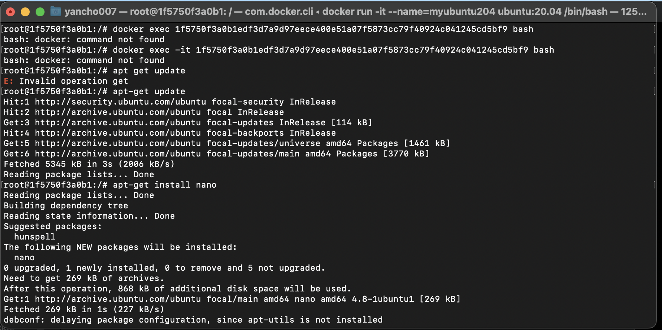

Step 6-Create new image (ubuntu + sysbench)

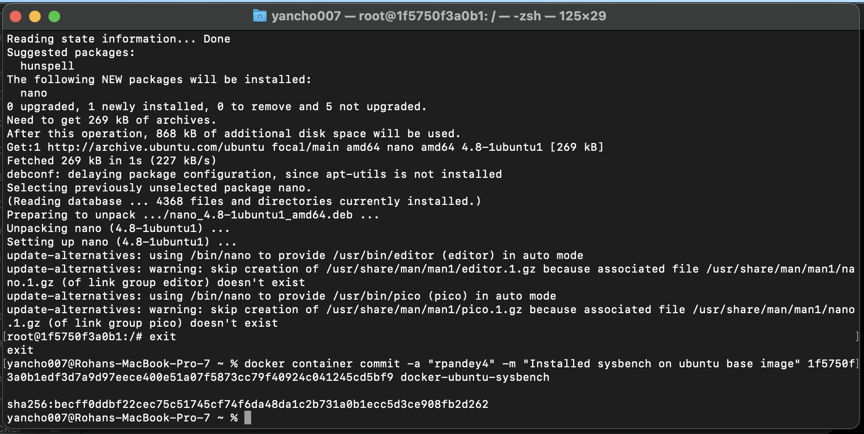

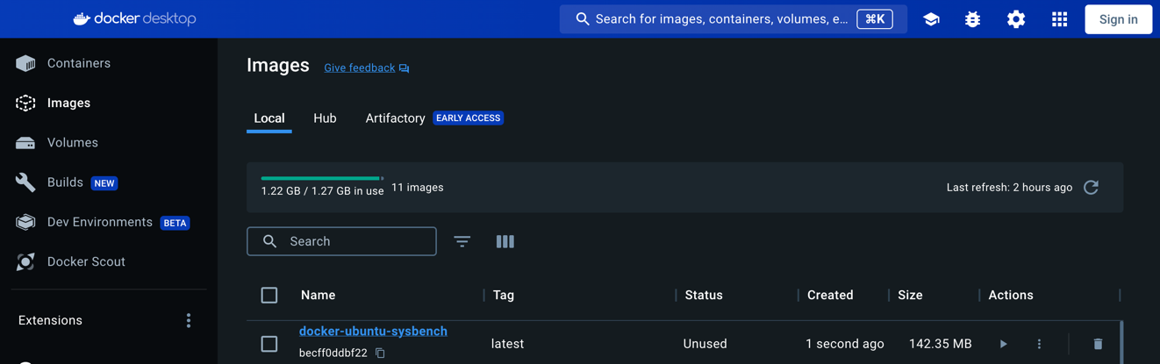

Step 7- Created container out of image

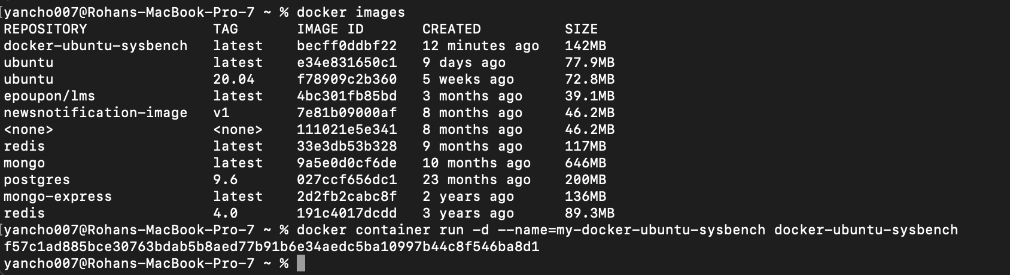

Step 8- Docker Base image running ( to be used to launch all configurations)



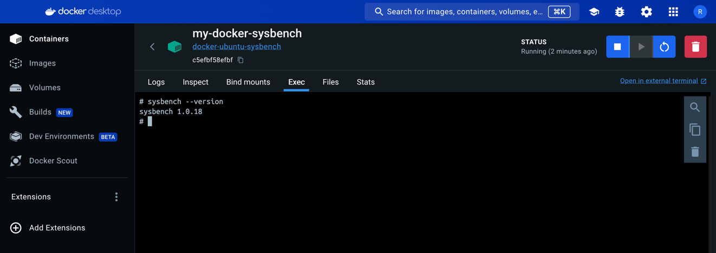

Image ID : c5efbf58efbf2218d8d7e7f0c63498768c0239b3a036251d80b039e901e76c4a

Starting docker in docker Desktop/CLI

We will run below test cases (Same as previous on 4 Docker configuration ) – (6*4) ->24 Tests

**2 CPU cases-**

* Test Case 0: Limiting the total execution time to 30 seconds: sysbench --test=cpu --time=45 run
* Test Case 1: sysbench --test=cpu --cpu-max-prime=100 --time=45 run
* Test Case 2: sysbench --test=cpu --cpu-max-prime=1000 --time=45 run

**2 memory cases-**

The --memory-block-size option in Sysbench is used to define the block size for memory allocation and deallocation operations. This option is relevant when running memory-related tests with Sysbench. Below are a few test cases for --memory-block-size:-

Test Case:

* sysbench memory --memory-block-size=16M run
* sysbench memory --memory-block-size=8k run

**2 fileio cases-**

**Test Case 1 (Sequential R/W) :** Creating test files of total size 1GB.

* sysbench --num-threads=14 --test=fileio --file-total-size=1G --max-time=100 --file-test-mode=seqwr prepare
* Running sequential read/write workload for 300 s
* sysbench --num-threads=14 --test=fileio --file-total-size=1G --file-test-mode=seqwr --max-time=100 --max-requests=0 run

**Test Case 2 (Random R/W):** Creating test files of total size 2GB.

* sysbench --num-threads=14 --test=fileio --file-total-size=2G --max-time=100 --file-test-mode= rndrw prepare
* sysbench --num-threads=14 --test=fileio --file-total-size=2G --file-test-mode= rndrw --max-time=100 --max-requests=0 run
* sysbench --test=fileio --file-total-size=2G cleanup

**Docker Configuration 1->**(1b304231bc5a)

docker run -it --cpus=4 --memory=4096M docker-ubuntu-sysbench

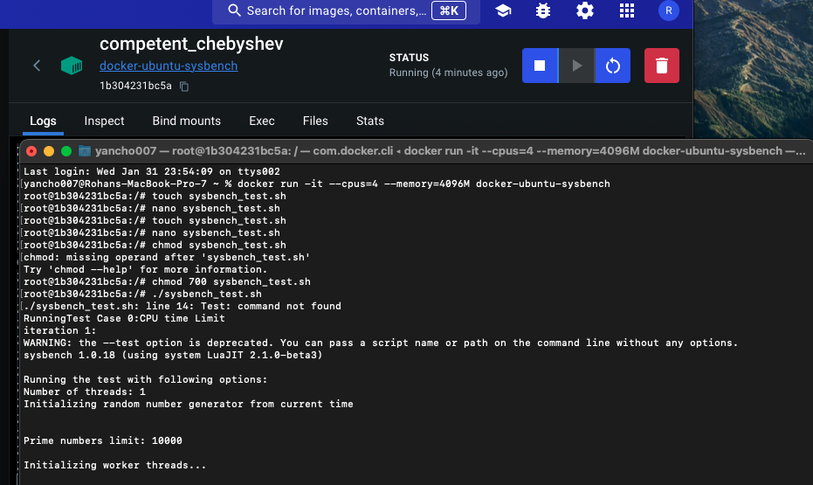

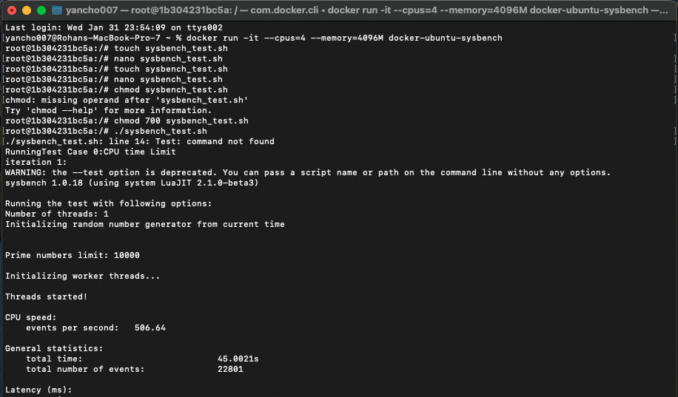

[**Test results and config bash scripts**](https://drive.google.com/drive/folders/1JPTe29cmfYDJz9iRWk4scmLiGF3gEvwY?usp=drive_link)

**DOCKER HISTORY-**

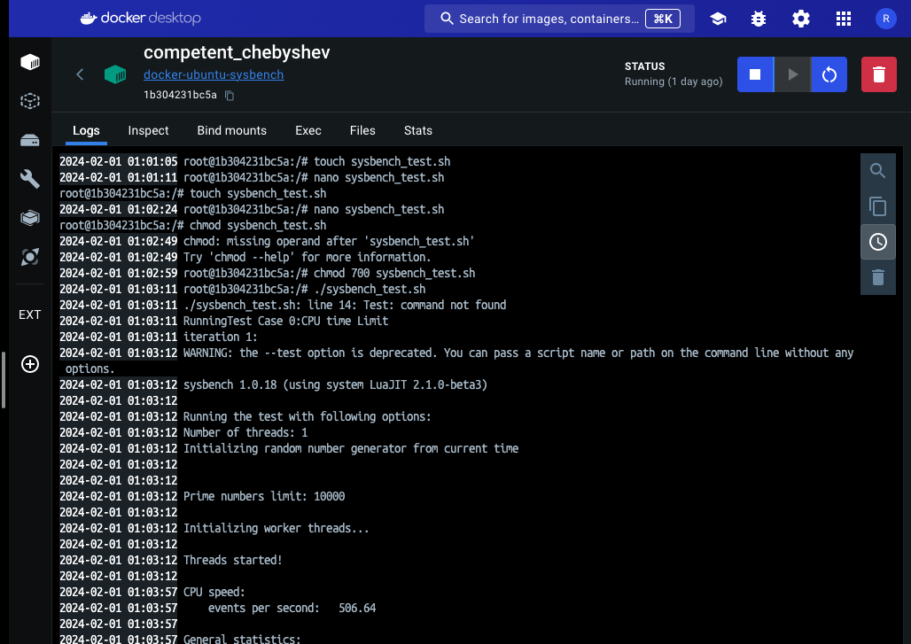

[**Test results and config bash scripts**](https://drive.google.com/drive/folders/1JPTe29cmfYDJz9iRWk4scmLiGF3gEvwY?usp=drive_link)

**Docker Configuration 2-> (**d6a1b07aa500)

docker run -it --cpus=8 --memory=8192M docker-ubuntu-sysbench

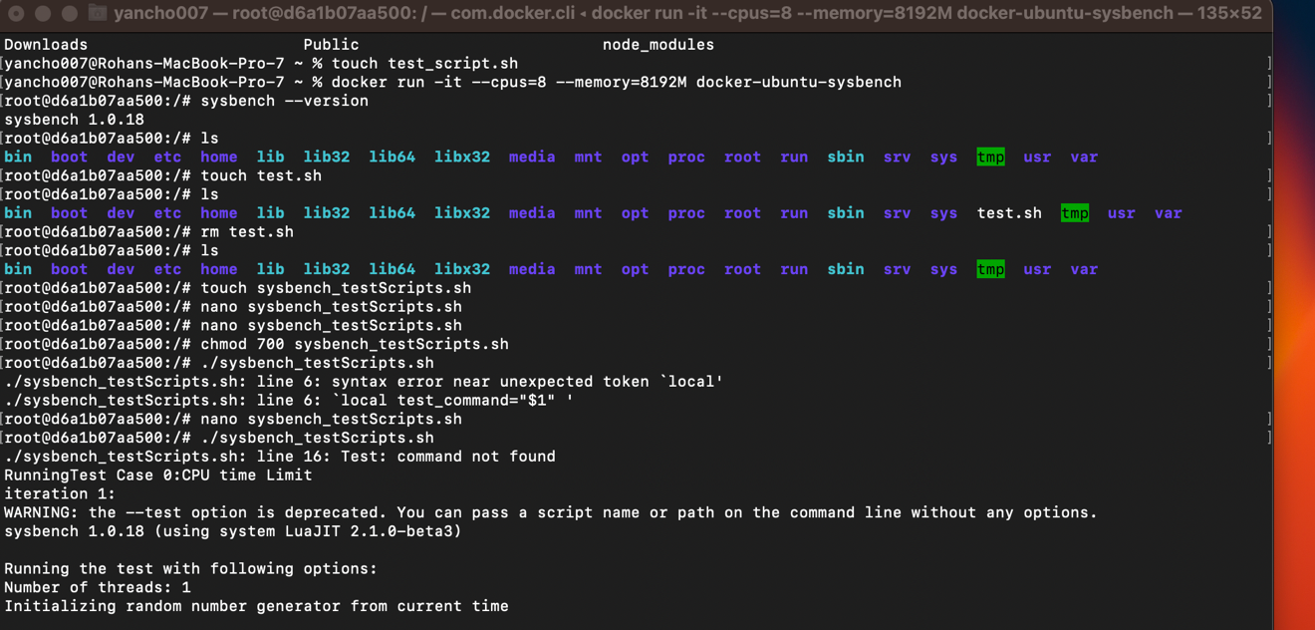

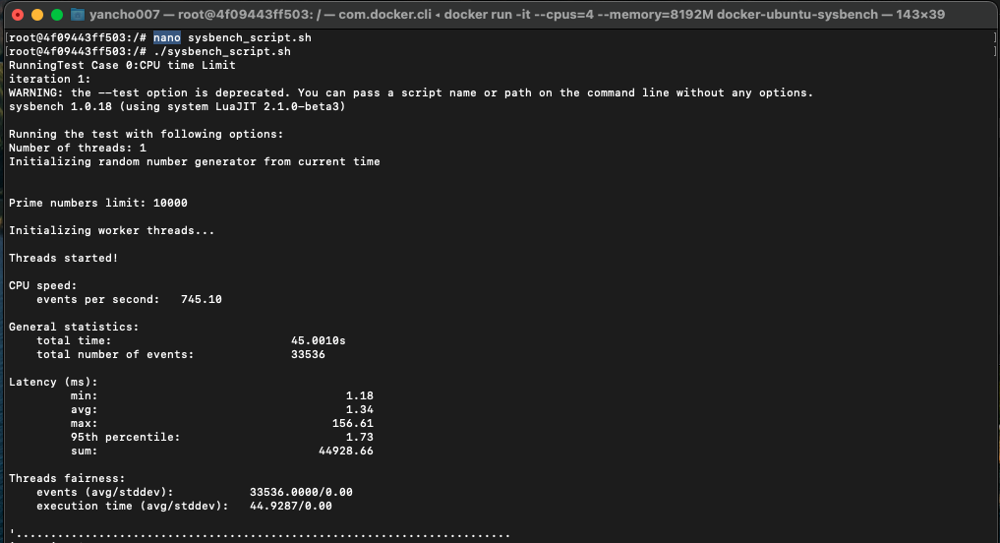

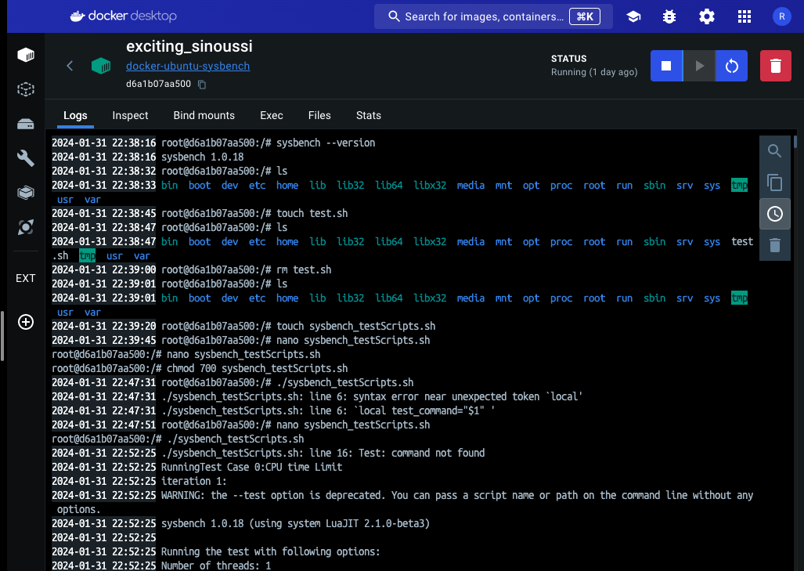

[**Test results and config bash scripts**](https://drive.google.com/drive/folders/1JPTe29cmfYDJz9iRWk4scmLiGF3gEvwY?usp=drive_link)

**Docker Configuration 3->(** 4f09443ff503)

docker run -it --cpus=4 --memory=8192M docker-ubuntu-sysbench

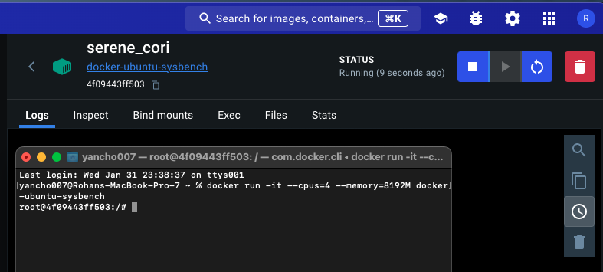

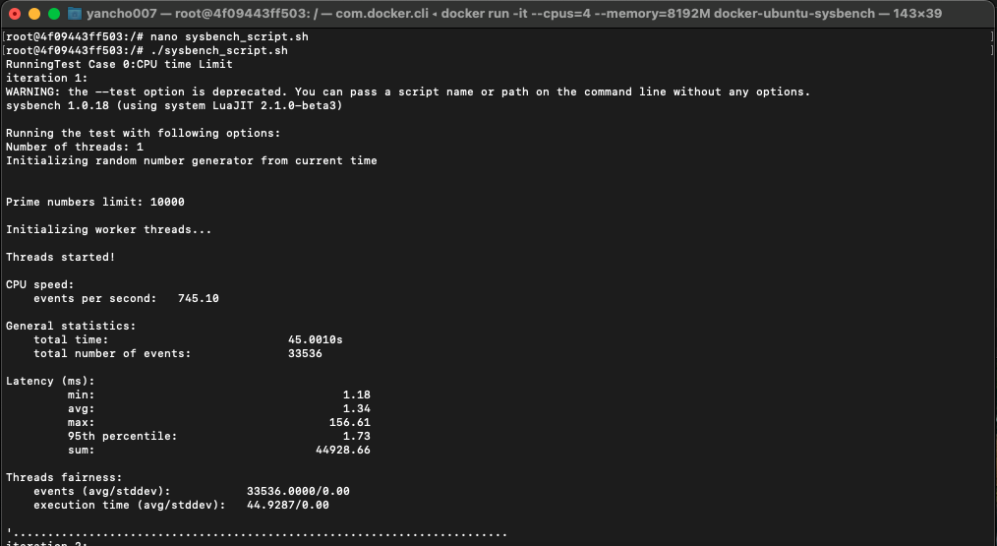

DOCKER HISTORY

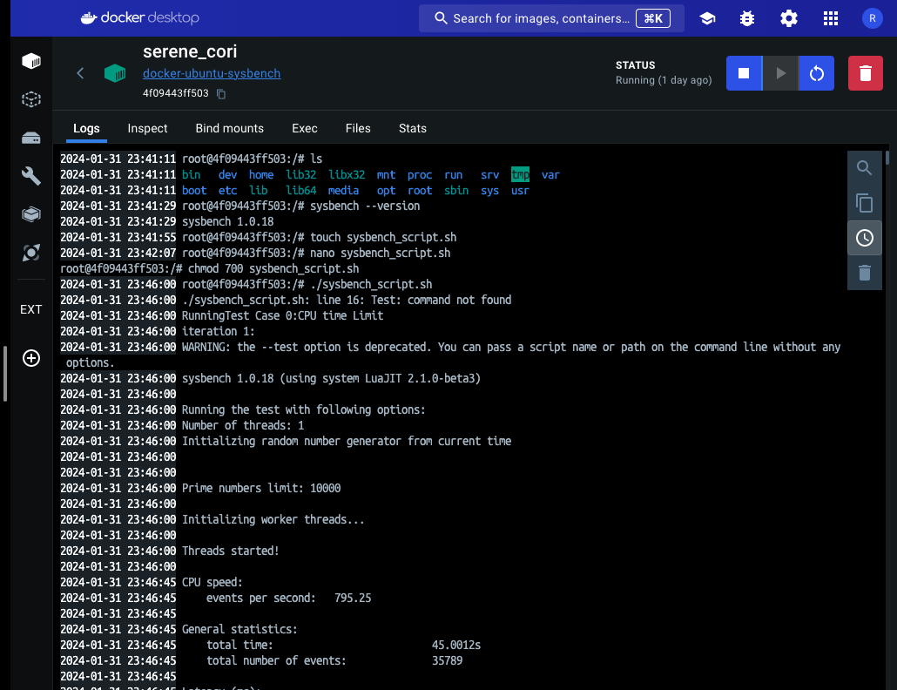

[**Test results and config bash scripts**](https://drive.google.com/drive/folders/1JPTe29cmfYDJz9iRWk4scmLiGF3gEvwY?usp=drive_link)

**Docker Configuration 4->(** **4cecdf9ada7599a60b9c74f3459e7cebf43fcceaeabc1bbd6581c253d0f40bb5)**

docker run -it --cpus=8 --memory=4096M docker-ubuntu-sysbench

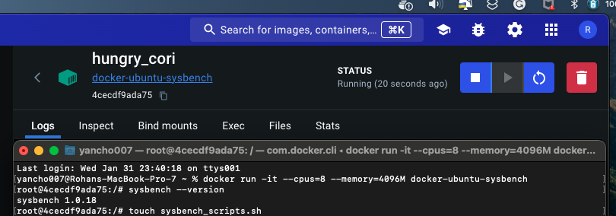

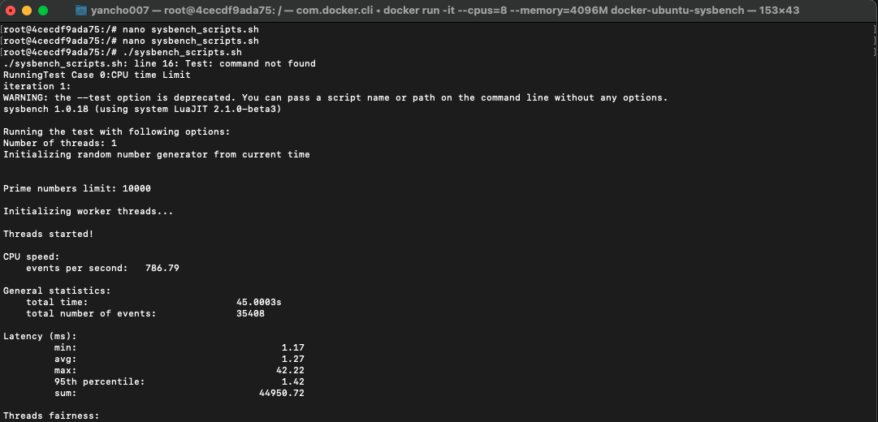

[**Test results and config bash scripts**](https://drive.google.com/drive/folders/1JPTe29cmfYDJz9iRWk4scmLiGF3gEvwY?usp=drive_link)

**Docker history**

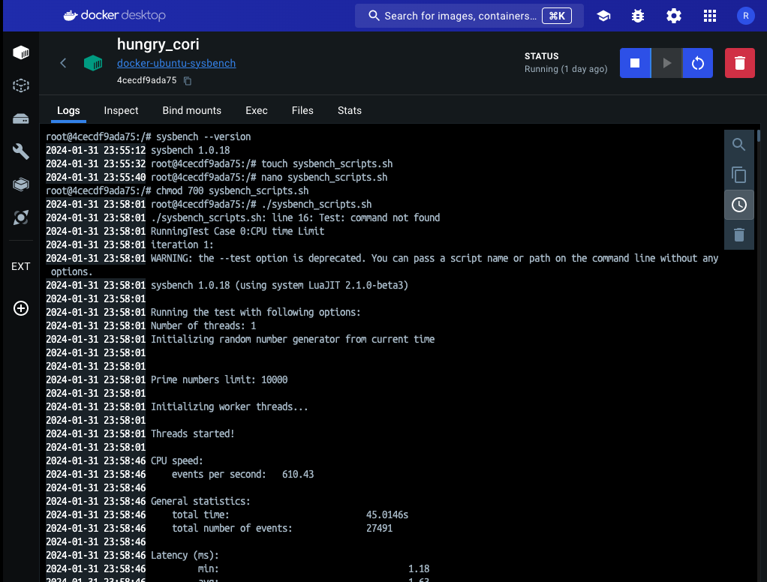

## Tests Comparison and summary

**Test Case 0- CPU**

**Limiting the total execution time to 30 seconds: sysbench --test=cpu --time=45 run**

|  |  |  |  |  |  |  |  |  |
| --- | --- | --- | --- | --- | --- | --- | --- | --- |
|  | **Prime No limit-10000 & Events per second-** | | | | | | | |
|  | **Qcow2** | | | | **raw** | | | |
| **Iteration No** | **Config 1** | **Config2** | **Config 3** | **Config4** | **Config 1** | **Config2** | **Config 3** | **Config4** |
| 1 | 236.24 | 238.12 | 247.83 | 247.17 | 247.49 | 251.54 | 251.23 | 239.93 |
| 2 | 241.76 | 245.24 | 228.48 | 231.98 | 240.26 | 240.25 | 210.32 | 250.32 |
| 3 | 253.96 | 240.95 | 220.61 | 243.82 | 253.46 | 239.42 | 208.32 | 251.68 |
| 4 | 254.82 | 248.75 | 256.31 | 256.84 | 254.58 | 254.54 | 225.65 | 240.65 |
| 5 | 252.45 | 250.30 | 235.32 | 238.45 | 238.15 | 248.25 | 234.80 | 244.15 |
| Average | 247.846 | 244.672 | 237.71 | 243.652 | 246.788 | 246.8 | 226.064 | 245.346 |

|  |  |  |  |  |
| --- | --- | --- | --- | --- |
|  | **Events per second** | | | |
|  | **Docker** | | | |
| **Iteration No** | **Config 1** | **Config2** | **Config 3** | **Config4** |
| 1 | 377.79 | 736.12 | 745.56 | 610.43 |
| 2 | 506.64 | 768.19 | 770.65 | 738.86 |
| 3 | 504.51 | 727.76 | 780.54 | 671.10 |
| 4 | 474.33 | 643.97 | 754.80 | 666.18 |
| 5 | 493.73 | 562.59 | 761.03 | 606.26 |
| Average | 471.4 | 687.726 | 762.516 | 658.566 |

**Conclusion:** According to our experiment, we observe that QEMU VM is faster than docker probable reasons-

1. Docker introduces some overhead due to containerization. The additional layer of abstraction and isolation might lead to slightly higher execution times compared to running directly on QEMU without containerization.
2. Docker allocates resources to containers, and sometimes these allocations might not perfectly match the requirements of the sysbench CPU test. QEMU might have more direct control over resources in this specific scenario.
3. Docker provides process-level isolation, while QEMU provides virtual machine-level isolation. Depending on the workload, VM-level isolation might have performance advantages over process-level isolation.

**Test Case 1- CPU**

**sysbench --test=cpu --cpu-max-prime=100 --time=45 run**

|  |  |  |  |  |  |  |  |  |
| --- | --- | --- | --- | --- | --- | --- | --- | --- |
|  | **CPU Max prime = 100- Events per second** | | | | | | | |
|  | **Qcow2** | | | | **raw** | | | |
| **Iteration No** | **Config 1** | **Config2** | **Config 3** | **Config4** | **Config 1** | **Config2** | **Config 3** | **Config4** |
| 1 | 36451.01 | 46246.64 | 43302.12 | 49312.21 | 57879.95 | 52095.85 | 44575.32 | 53320.75 |
| 2 | 47052.31 | 51119.63 | 37204.32 | 37204.19 | 54439.45 | 44122.45 | 39461.45 | 44122.61 |
| 3 | 52111.31 | 48093.61 | 40317.65 | 46246.64 | 58163.85 | 54439.25 | 52095.28 | 49880.81 |
| 4 | 49312.21 | 51270.25 | 46746.45 | 48093.61 | 54122.35 | 46241.15 | 52870.91 | 46241.37 |
| 5 | 45312.03 | 50409.32 | 34112.85 | 51270.25 | 44218.75 | 39461.75 | 47716.54 | 46682.19 |
| Average | 46047.77 | 49427.89 | 40336.67 | 46425.38 | 53764.87 | 47272.09 | 47343.95 | 48049.54 |

|  |  |  |  |  |
| --- | --- | --- | --- | --- |
|  | **Events per second** | | | |
|  | **Docker** | | | |
| **Iteration No** | **Config 1** | **Config2** | **Config 3** | **Config4** |
| 1 | 500735.87 | 359566.52 | 484078.55 | 414841.26 |
| 2 | 476663.42 | 429460.40 | 402740.40 | 409737.01 |
| 3 | 379819.76 | 371058.35 | 416013.09 | 397638.15 |
| 4 | 423306.76 | 434396.59 | 384661.09 | 396469.40 |
| 5 | 370637.05 | 455412.29 | 413151.87 | 446677.05 |
| Average | 430232.57 | 409978.83 | 420129.85 | 413072.57 |

**Conclusion:** According to our experiment, we observe that QEMU qcow2 VM is faster than docker & docker is faster then QEMU raw image probable reasons-

1. QEMU with qcow2 might benefit from caching mechanisms specific to the qcow2 format, providing advantages in scenarios where caching plays a significant role. Docker, depending on its storage driver and caching strategy, might introduce different caching behavior.
2. The qcow2 format typically introduces some overhead due to compression and snapshot features. If the workload involves significant storage operations, the qcow2 format might perform better than raw, which is a straightforward format
3. As Docker relies on the host OS's kernel, interactions between the workload, Docker, and the kernel could be influencing the results. QEMU with a raw image operates at a more isolated level.

**Test Case 2- CPU**

**sysbench --test=cpu --cpu-max-prime=1000 --time=45 run**

|  |  |  |  |  |  |  |  |  |
| --- | --- | --- | --- | --- | --- | --- | --- | --- |
|  | **CPU Max prime = 1000 -Events per second** | | | | | | | |
|  | **Qcow2** | | | | **raw** | | | |
| **Iteration No** | **Config 1** | **Config2** | **Config 3** | **Config4** | **Config 1** | **Config2** | **Config 3** | **Config4** |
| 1 | 4512.75 | 4702.98 | 4525.15 | 4704.53 | 4960.84 | 4106.75 | 4241.05 | 4402.15 |
| 2 | 4721.78 | 4745.36 | 4646.23 | 4412.31 | 5008.15 | 5036.75 | 4106.75 | 4553.73 |
| 3 | 4572.24 | 4704.53 | 4403.52 | 4677.80 | 5025.25 | 4505.67 | 3677.25 | 4547.27 |
| 4 | 4704.53 | 4572.24 | 4721.78 | 4821.31 | 4960.84 | 3677.25 | 4335.73 | 4505.67 |
| 5 | 4646.23 | 4685.35 | 4590.95 | 4671.95 | 5036.75 | 4568.67 | 4568.67 | 4213.29 |
| Average | 4631.506 | 4682.092 | 4577.526 | 4657.58 | 4998.366 | 4379.018 | 4185.89 | 4444.422 |

|  |  |  |  |  |
| --- | --- | --- | --- | --- |
|  | **Events per second** | | | |
|  | **Docker** | | | |
| **Iteration No** | **Config 1** | **Config2** | **Config 3** | **Config4** |
| 1 | 16945.80 | 17689.12 | 17505.76 | 17451.94 |
| 2 | 17817.71 | 18133.35 | 17473.96 | 18175.85 |
| 3 | 17338.43 | 18086.14 | 18154.96 | 17875.99 |
| 4 | 18153.66 | 19359.64 | 17924.09 | 18605.95 |
| 5 | 17994.89 | 18482.04 | 18656.93 | 19367.92 |
| Average | 17650.098 | 18350.058 | 17943.14 | 18295.53 |

**Conclusion 1:** As we see, when we increase the cpu-max-prime argument value the number of events per second decreases for our current experimental configuration. **&**  we observe that QEMU VM is faster than docker for number of events probable reasons-

1. A higher value for cpu-max-prime indicates a more intense CPU workload. In such scenarios, the virtualization overhead introduced by Docker may become more noticeable compared to QEMU. QEMU might have optimizations or configurations that handle highly CPU-intensive workloads more efficiently.
2. he increased CPU intensity might put more strain on the resource allocation and isolation mechanisms of Docker. QEMU, operating at the virtual machine level, may handle such workloads with less overhead compared to Docker's process-level isolation.
3. As the CPU workload intensifies, the impact of storage-related operations, including caching, might become more pronounced. QEMU with its qcow2 format or raw image might exhibit different caching behaviors compared to Docker with its storage drivers.

**CPU Test Case 3- Memory**

**sysbench memory --memory-block-size=16M run**

|  |  |  |  |  |  |  |  |  |
| --- | --- | --- | --- | --- | --- | --- | --- | --- |
|  | **CPU memory- 16 M block-Operations per second** | | | | | | | |
|  | **Qcow2** | | | | **raw** | | | |
| **Iteration No** | **Config 1** | **Config2** | **Config 3** | **Config4** | **Config 1** | **Config2** | **Config 3** | **Config4** |
| 1 | 105.12 | 98.79 | 131.41 | 110.68 | 106.20 | 122.11 | 83.46 | 99.41 |
| 2 | 118.65 | 128.62 | 120.45 | 108.32 | 107.41 | 113.25 | 88.61 | 102.34 |
| 3 | 108.5 | 108.34 | 131.30 | 109.39 | 108.45 | 107.87 | 87.54 | 108.32 |
| 4 | 125.36 | 106.85 | 135.12 | 111.45 | 108.15 | 120.02 | 90.25 | 104.78 |
| 5 | 121.52 | 120.08 | 111.62 | 109.63 | 106.20 | 109.57 | 94.31 | 101.65 |
| Average | 115.83 | 112.536 | 125.98 | 109.894 | 107.282 | 114.564 | 88.834 | 103.3 |

|  |  |  |  |  |
| --- | --- | --- | --- | --- |
|  | **Events per second** | | | |
|  | **Docker** | | | |
| **Iteration No** | **Config 1** | **Config2** | **Config 3** | **Config4** |
| 1 | 404.14 | 414.54 | 692.12 | 488.25 |
| 2 | 474.04 | 400.20 | 647.32 | 602.73 |
| 3 | 518.63 | 428.86 | 708.62 | 732.28 |
| 4 | 520.08 | 535.69 | 625.23 | 719.74 |
| 5 | 495.86 | 536.35 | 681.60 | 728.44 |
| Average | 482.55 | 463.12 | 670.97 | 654.28 |

**Conclusion 1:** As we see, comparing the performance of QEMU and Docker in a sysbench memory test with a memory block size of 16M, and finding that QEMU is faster than Docker, probable reasons-

1. Docker relies on the host OS's memory management for containerized applications, while QEMU manages memory for virtual machines. The way each system allocates and manages memory for the specified block size can impact performance
2. Docker introduces some level of overhead due to containerization. The additional layer of abstraction and isolation might have a more noticeable impact on memory-related tests, especially when compared to the more direct memory access available in QEMU's virtual machine environment.
3. As the CPU workload intensifies, the impact of storage-related operations, including caching, might become more pronounced. QEMU with its qcow2 format or raw image might exhibit different caching behaviors compared to Docker with its storage drivers.

**Test Case 4- Memory**

**sysbench memory --memory-block-size=8k run**

|  |  |  |  |  |  |  |  |  |
| --- | --- | --- | --- | --- | --- | --- | --- | --- |
|  | **CPU memory- 8k block-Events per second** | | | | | | | |
|  | **Qcow2** | | | | **raw** | | | |
| **Iteration No** | **Config 1** | **Config2** | **Config 3** | **Config4** | **Config 1** | **Config2** | **Config 3** | **Config4** |
| 1 | 84696.53 | 80792.26 | 86452.62 | 78558.83 | 93301.81 | 69579.47 | 859935.18 | 72180.54 |
| 2 | 80986.86 | 82300.12 | 84696.53 | 80455.46 | 93002.95 | 85361.76 | 8231547.2 | 79213.65 |
| 3 | 80455.46 | 80986.86 | 86514.16 | 88501.52 | 93540.10 | 85361.76 | 842484.57 | 74764.65 |
| 4 | 90662.61 | 81300.12 | 84512.52 | 90662.61 | 94523.45 | 67544.96 | 813625.45 | 81245.95 |
| 5 | 86514.16 | 86601.12 | 87533.20 | 83195.63 | 92854.56 | 75213.45 | 863256.85 | 80861.72 |
|  | 84663.124 | 82396.096 | 85941.806 | 84274.81 | 93444.574 | 76612.28 | 2322169.85 | 77653.302 |

|  |  |  |  |  |
| --- | --- | --- | --- | --- |
|  | **Total operations per second** | | | |
|  | **Docker** | | | |
| **it No** | **Config 1** | **Config2** | **Config 3** | **Config4** |
| 1 | 695550.76 | 808425.76 | 1019472.74 | 1188424.24 |
| 2 | 571048.28 | 900319.49 | 1013454.47 | 1183309.75 |
| 3 | 529328.04 | 844760.79 | 1005276.71 | 1164973.45 |
| 4 | 184493.17 | 772844.52 | 1049588.58 | 1152173.37 |
| 5 | 377682.02 | 796758.88 | 10012354.65 | 1171149.74 |
|  | 471620.454 | 824621.888 | 2820029.43 | 1172006.11 |

**Conclusion:** According to our experiment, we observe that with decrease in memory block size the number of events per second increased in all 3 cases. Mainly related to the impact of memory block size on the efficiency of memory operations and caching. When dealing with smaller memory block sizes. however config 3 & 4 of docker performs better then QEMU, however at lower config QEMU performs well. Probable reasons-

* Smaller memory block sizes are more likely to fit within CPU caches, such as L1 and L2 caches. This allows for faster access to memory, as data can be retrieved from these caches more quickly compared to fetching from the main memory. As a result, the overall performance of memory operations improves.
* Smaller memory block sizes can lead to lower memory access latencies. Accessing smaller chunks of memory requires less time to fetch data, reducing the overall time it takes to perform memory operations.

**File Io Test Case 5-**

**(Sequential R/W) :** Creating test files of total size 1GB.

* sysbench --num-threads=14 --test=fileio --file-total-size=1G --max-time=100 --file-test-mode=seqwr prepare
* Running sequential read/write workload for 300 s sysbench --num-threads=14 --test=fileio --file-total-size=1G --file-test-mode=seqwr --max-time=100 --max-requests=0 run
* sysbench --test=fileio --file-total-size=1G cleanup

|  |  |  |  |  |  |  |  |  |
| --- | --- | --- | --- | --- | --- | --- | --- | --- |
|  | **File io 1GB Sequential W/R** | | | | | | | |
|  | **Qcow2** | | | | **raw** | | | |
| **It. No** | **Config 1** | **Config2** | **Config 3** | **Config4** | **Config 1** | **Config2** | **Config 3** | **Config4** |
| 1 | reads/s: 0.00 writes/s:1589.43 fsyncs/s:2051.38 | reads/s: 0.00 writes/s:1218.43 fsyncs/s:1576.38 | reads/s: 0.00 writes/s:1515.94 fsyncs/s:1957.38 | reads/s: 0.00 writes/s:1378.94 fsyncs/s:1781.38 | reads/s: 0.00 writes/s:1426.20 fsyncs/s:1825.76 | reads/s: 0.00 writes/s:912.23 fsyncs/s:1168.66 | reads/s: 0.00 writes/s:1142.40 fsyncs/s:1462.77 | reads/s: 0.00 writes/s:1153.87 fsyncs/s:1477.93 |
| 2 | reads/s: 0.00 writes/s:1027.73 fsyncs/s:1332.21 | reads/s: 0.00 writes/s:1154.98 fsyncs/s:1495.60 | reads/s: 0.00 writes/s:1589.43 fsyncs/s:2051.38 | reads/s: 0.00 writes/s:1422.94 fsyncs/s:1837.38 | reads/s: 0.00 writes/s:1413.29 fsyncs/s:1810.19 | reads/s: 0.00 writes/s:995.25 fsyncs/s:1275.44 | reads/s: 0.00 writes/s:1076.82.3 fsyncs/s:1378.66 | reads/s: 0.00 writes/s:976.40 fsyncs/s:1250.77 |
| 3 | reads/s: 0.00 writes/s:1515.94 fsyncs/s:1957.38 | reads/s: 0.00 writes/s:1156.50 fsyncs/s:1497.98 | reads/s: 0.00 writes/s:1576.43 fsyncs/s:2035.38 | reads/s: 0.00 writes/s:1420.01 fsyncs/s:1834.23 | reads/s: 0.00 writes/s:1473.33 fsyncs/s:1886.80 | reads/s: 0.00 writes/s:1017.60 fsyncs/s:1303.81 | reads/s: 0.00 writes/s:1009.23 fsyncs/s:1292.25 | reads/s: 0.00 writes/s:1219.40 fsyncs/s:1561.77 |
| 4 | reads/s: 0.00 writes/s:1378.94 fsyncs/s:1781.38 | reads/s: 0.00 writes/s:1330.74 fsyncs/s:1720.00 | reads/s: 0.00 writes/s:1378.94 fsyncs/s:1781.38 | reads/s: 0.00 writes/s:1301.47 fsyncs/s:1683.46 | reads/s: 0.00 writes/s:828.05 fsyncs/s:1061.06 | reads/s: 0.00 writes/s:1205.40 fsyncs/s:1544.00 | reads/s: 0.00 writes/s:1352.23 fsyncs/s:1731.66 | reads/s: 0.00 writes/s:1264.40 fsyncs/s:1618.77 |
| 5 | reads/s: 0.00 writes/s:1154.98 fsyncs/s:1495.60 | reads/s: 0.00 writes/s:1027.73 fsyncs/s:1332.21 | reads/s: 0.00 writes/s:1154.98 fsyncs/s:1495.60 | reads/s: 0.00 writes/s:1218.43 fsyncs/s:1576.38 | reads/s: 0.00 writes/s:995.25 fsyncs/s:1275.44 | reads/s: 0.00 writes/s:1076.82.3 fsyncs/s:1378.66 | reads/s: 0.00 writes/s:1153.87 fsyncs/s:1477.93 | reads/s: 0.00 writes/s:912.23 fsyncs/s:1168.66 |

|  |  |  |  |  |
| --- | --- | --- | --- | --- |
|  | **File io 1GB Sequential W/R** | | | |
|  | **Docker** | | | |
| **Iteration No** | **Config 1** | **Config2** | **Config 3** | **Config4** |
| 1 | reads/s: 0.00 writes/s:2557.43 fsyncs/s:3290.38 | reads/s: 0.00 writes/s:6834.43 fsyncs/s:8765.38 | reads/s: 0.00 writes/s:9020.43 fsyncs/s:111563.38 | reads/s: 0.00 writes/s:11797.43 fsyncs/s:15118.38 |
| 2 | reads/s: 0.00 writes/s:2827.98 fsyncs/s:3637.60 | reads/s: 0.00 writes/s:5460.43 fsyncs/s:7006.38 | reads/s: 0.00 writes/s:8532.43 fsyncs/s:10939.38 | reads/s: 0.00 writes/s:11357.43 fsyncs/s:14555.38 |
| 3 | reads/s: 0.00 writes/s:3108.50 fsyncs/s:3997.98 | reads/s: 0.00 writes/s:6059.43 fsyncs/s:7774.38 | reads/s: 0.00 writes/s:6124.43 fsyncs/s:7857.38 | reads/s: 0.00 writes/s:10029.43 fsyncs/s:12854.38 |
| 4 | reads/s: 0.00 writes/s:3220.74 fsyncs/s:4140.00 | reads/s: 0.00 writes/s:4680.43 fsyncs/s:6008.38 | reads/s: 0.00 writes/s:5595.43 fsyncs/s:7179.38 | reads/s: 0.00 writes/s:115..43 fsyncs/s:150.38 |
| 5 | reads/s: 0.00 writes/s:4093.73 fsyncs/s:5256.21 | reads/s: 0.00 writes/s:2548.43 fsyncs/s:3279.38 | reads/s: 0.00 writes/s:6949.43 fsyncs/s:8912.38 | reads/s: 0.00 writes/s:10285.43 fsyncs/s:13183.38 |

**Conclusion 1:** As we see, comparing the performance of QEMU and Docker in a sysbench fileio test docker performs much better then QEMU. At higher configurations the write speed of docker increases in multifold. Few reasons for this behaviour-

1. QEMU with qcow2 and raw images operates in a virtualized environment, while Docker operates at the container level. Depending on the underlying storage and access mechanisms, Docker may have more direct access to the host's storage, leading to faster sequential read/write operations.
2. Docker's resource allocation and isolation mechanisms, specifically designed for containerized applications, might be more efficient in handling sequential read/write workloads. QEMU's virtualization layer may introduce additional overhead.
3. he choice of filesystem on the host system where Docker is running can impact file I/O performance. Docker containers typically share the host's filesystem, and if it uses a filesystem optimized for sequential operations, it could outperform QEMU with qcow2 and raw images.

**File Io Test Case 6-**

**Test Case 2 (Random R/W):** Creating test files of total size 2GB.

* sysbench --num-threads=14 --test=fileio --file-total-size=2G --max-time=100 --file-test-mode= rndrw prepare
* sysbench --num-threads=14 --test=fileio --file-total-size=2G --file-test-mode= rndrw --max-time=100 --max-requests=0 run
* sysbench --test=fileio --file-total-size=2G cleanup

|  |  |  |  |  |  |  |  |  |  |  |  |
| --- | --- | --- | --- | --- | --- | --- | --- | --- | --- | --- | --- |
|  | **File io 2GB Random W/R** | | | | | | | | | | |
|  | **Qcow2** | | | | | | **raw** | | | | |
| **It. No** | **Config 1** | | **Config2** | **Config 3** | **Config4** | | **Config 1** | **Config2** | **Config 3** | | **Config4** |
| 1 | reads/s: 650.53 writes/s:433.693 fsyncs/s:1403.29 | | reads/s: 714.53 writes/s:476.693 fsyncs/s:1541.22 | reads/s: 708.53 writes/s:472.93 fsyncs/s:1529.29 | reads/s: 670.53 writes/s:409.693 fsyncs/s:1477.29 | | reads/s: 614.53 writes/s:446.693 fsyncs/s:1311.29 | reads/s: 510.86 writes/s:340.57 fsyncs/s:1090.69 | reads/s: 659.66 writes/s:439.23 fsyncs/s:1408.66 | | reads/s: 661.66 writes/s:441.23 fsyncs/s:1412.66 |
| 2 | reads/s: 735.53 writes/s:490.693 fsyncs/s:1587.29 | | reads/s: 721.53 writes/s:480.693 fsyncs/s:1556.29 | reads/s: 738.53 writes/s:492.63 fsyncs/s:1591.29 | reads/s: 689.53 writes/s:459.69 fsyncs/s:1487.29 | | reads/s: 631.96 writes/s:421.31 fsyncs/s:1348.72 | reads/s: 567.09 writes/s:378.06 fsyncs/s:1209.87 | reads/s: 678.70 writes/s:452.47 fsyncs/s:1448.14 | | reads/s: 595.66 writes/s:396.23 fsyncs/s:1270.66 |
| 3 | reads/s: 714.53 writes/s:476.693 fsyncs/s:1542.29 | | reads/s: 705.53 writes/s:470.693 fsyncs/s:1522.29 | reads/s: 756.53 writes/s:504.693 fsyncs/s:1630.29 | reads/s: 673.53 writes/s:449.13 fsyncs/s:1454.29 | | reads/s: 592.45 writes/s:394.97 fsyncs/s:1265.18 | reads/s: 309.15 writes/s:206.10 fsyncs/s:660.10 | reads/s: 568.22 writes/s:378.23 fsyncs/s:1212.66 | | reads/s: 615.66 writes/s:410.23 fsyncs/s:1312.66 |
| 4 | reads/s: 664.53 writes/s:442.63 fsyncs/s:1433.29 | | reads/s: 571.53 writes/s:380.693 fsyncs/s:1234.29 | reads/s: 674.53 writes/s:449.63 fsyncs/s:1457.29 | reads/s: 665.53 writes/s:443.49 fsyncs/s:1436.29 | | reads/s: 649.25 writes/s:432.83 fsyncs/s:1385.33 | reads/s: 402.29 writes/s:268.19 fsyncs/s:858.35 | reads/s: 590.67 writes/s:393.78 fsyncs/s:1261.66 | | reads/s: 616.66 writes/s:410.23 fsyncs/s:1315.66 |
| 5 | reads/s: 658.53 writes/s:439.693 fsyncs/s:1423.29 | | reads/s: 647.53 writes/s:431.693 fsyncs/s:1399.29 | reads/s: 684.53 writes/s:457.693 fsyncs/s:1481.29 | reads/s: 667.53 writes/s:445.693 fsyncs/s:1440.29 | | reads/s: 0.00 writes/s:1027.73 fsyncs/s:1332.21 | reads/s: 430.15 writes/s:286.77 fsyncs/s:918.56 | reads/s: 491.66 writes/s:327.23 fsyncs/s:1049.66 | | reads/s: 491.66 writes/s:327.23 fsyncs/s:1049.66 |
|  | | **File io 2GB Random W/R** | | | | | | | |
|  | | **Docker** | | | | | | | |
| **Iteration No** | | **Config 1** | | **Config2** | | **Config 3** | | **Config4** | |
| 1 | | reads/s: 1749.6 writes/s:1166.43 fsyncs/s:3746.38 | | reads/s: 1667 writes/s:1111.43 fsyncs/s:3575.38 | | reads/s: 1621 writes/s:1080.43 fsyncs/s:3476.38 | | reads/s: 3713 writes/s:2475.43 fsyncs/s:7938.38 | |
| 2 | | reads/s1.3500 writes/s:0.900 fsyncs/s:3.030 | | reads/s: 1775.6 writes/s:1183.43 fsyncs/s:3805.38 | | reads/s: 1707.6 writes/s:1137.43 fsyncs/s:3658.38 | | reads/s: 4344.6 writes/s:2896.43 fsyncs/s:9285.38 | |
| 3 | | reads/s: 2774.86 writes/s:1849.50 fsyncs/s:5937.98 | | reads/s: 1848.38 writes/s:1232.43 fsyncs/s:3960.38 | | reads/s: 1689.38 writes/s:1126.43 fsyncs/s:3621.38 | | reads/s: 4855.6 writes/s:3237.43 fsyncs/s:10376.38 | |
| 4 | | reads/s: 2793 writes/s:1862.74 fsyncs/s:5977.00 | | reads/s: 2295.5 writes/s:1530.43 fsyncs/s:4915.38 | | reads/s: 1830.5 writes/s:1220.43 fsyncs/s:3922.38 | | reads/s: 527.6 writes/s:351.43 fsyncs/s:1129.38 | |
| 5 | | reads/s: 3149.96 writes/s:2099.73 fsyncs/s:6736.21 | | reads/s: 2225.49 writes/s:1483.43 fsyncs/s:4764.79 | | reads/s: 1748.49 writes/s:1165.43 fsyncs/s:3747.79 | | reads/s: 4168.6 writes/s:2778.43 fsyncs/s:8910.38 | |

**Conclusion 1:** As we see with 2gb random w/r performance is QEMU & docker is more &, comparing the performance of QEMU and Docker in a sysbench fileio test docker performs much better then QEMU. At higher configurations the write speed of docker increases in multifold. Few reasons for this behaviour-

1. QEMU with qcow2 and raw images operates in a virtualized environment, while Docker operates at the container level. Depending on the underlying storage and access mechanisms, Docker may have more direct access to the host's storage, leading to faster sequential read/write operations.
2. QEMU with qcow2 and raw images has different image formats with distinct characteristics. Qcow2 introduces additional features like compression and snapshots, but it may have overhead. Raw images are more straightforward. Depending on the workload and the nature of data, these formats can impact read and write performance differently.
3. We observe if our application primarily performs large, sequential data transfers, then optimizing for sequential I/O may be beneficial. On the other hand, if your application involves frequent, non-linear access to data, optimizing for random I/O is more appropriate.

## Git Repository Information:

|  |  |
| --- | --- |
| Account name | rohanpandeymech |
| Repository name | COEN-241-Cloud-Computing |
| Folder which contains HW1 | HW1 |
| Link to repository | <https://github.com/rohanpandeymech/CloudComputing/tree/main/HW1> |
| Commit ID | 8a145d814fccca352317d047ffa65c1016ff55e8 |